Moonlighting Request Steps
- Trainee reviews the Moonlighting eligibility & policy posted on GME website.
- Trainee approaches program to discuss their options.
- If program agrees to the request, Program Leadership completes the Microsoft Form request.
- GME Office places trainee on non-primary Moonlighting rotation for the AY in New Innovations.
- GME Office assigns the Moonlighting Rotation checklist in New Innovations [with imbedded form] which includes:
  - Required review of eligibility & policy (listed on GME website) – check the box to confirm completion
  - Moonlighting agreement provided – check the box to confirm receipt
  - Upload box for signed agreement provided in previous step
    - Program Director must sign at bottom of Page 1
    - Trainee initials next to each statement on Page 2
    - Program Director and Trainee must sign at bottom of Page 2
  - Imbedded form for credentials with required document uploads & expiration dates (which will be attached to their personnel records)
- Checklist items are held for review by the GME Office. Once reviewed & approved, the trainee & program will receive an email approval.
  - If moonlighting at with Hospitalist Medicine, Hailey Laws will be copied. Employers will also be copied (Terra Mouser for BJH and Suzzi Harper for SLCH).
  - Approvals only good for the current Academic Year (July 1 – June 30).

Moonlighting Checklist assigned to trainee in New Innovations
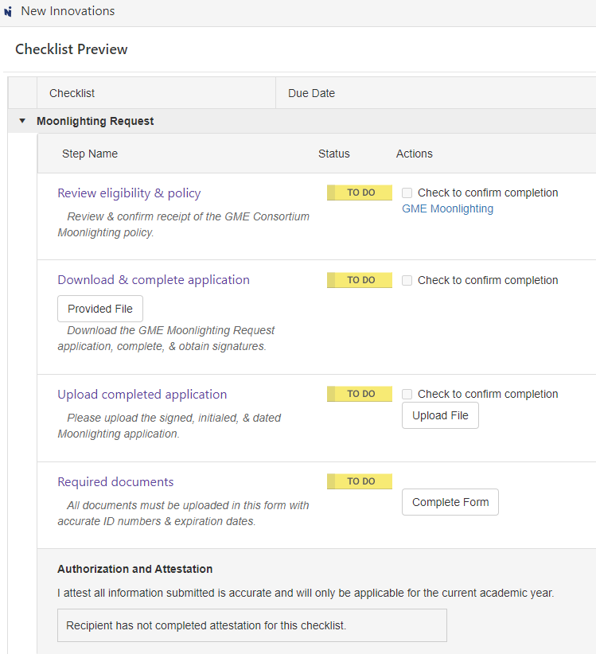

Moonlighting Form Contents
Trainees must upload a PDF copy of all supporting documents. This form comes to the GME Office for review of documents & once confirmed, all documents are attached to their Personnel File in New Innovations.
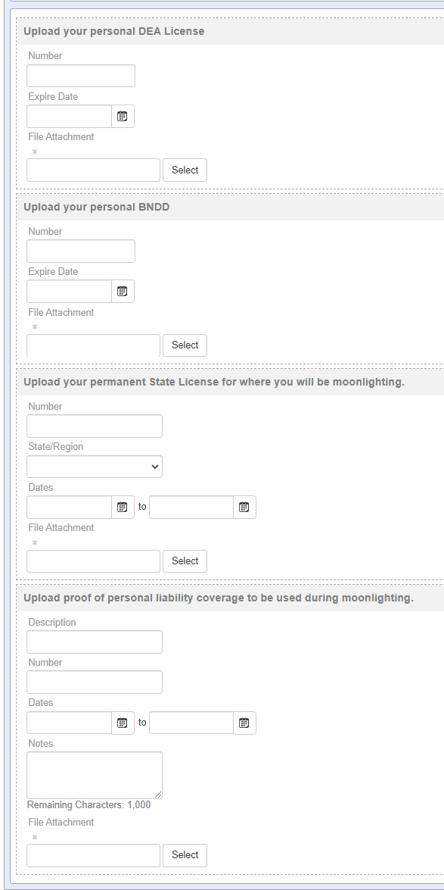

Moonlighting Request Form to be Completed by Trainee

